There exists a buyer and a seller
The seller has marginal cost of producing=0

The buyer has 2 valuation types which decides how he avlues the good giving his reservation value
$$b_{i}$$
With
$$b_{H}>b_{L}>0$$
The buyer’s payoff is
$$u_{i}\left(p,t\right)=δ^{t}·\left(b_{i}-p\right)$$
With $δ∈(0,1)$

a)
function of indifferencecurves

$$δ^{t}·\left(b_{i}-p(t)\right)=\overline{u}$$
$$\frac{d}{dt}δ^{t}·\left(b_{i}-p\left(t\right)\right)=0$$
$$\log\left(δ\right)·δ^{t}·\left(b_{i}-p\left(t\right)\right)-δ^{t}·\frac{dp}{dt}=0$$
$$⇔\frac{dp}{dt}=\left(b_{i}-p\left(t\right)\right)·\log\left(δ\right)$$

find indifference curves

$$δ^{t}·\left(b_{i}-p\right)=\overline{u}⇔\overline{u}·δ^{-t}=b_{i}-p⇔p(t)=b_{i}-\overline{u}·δ^{-t}$$

$$\frac{dp}{dt}=\left(b_{i}-p\left(t\right)\right)·\log\left(δ\right)=\left(b_{i}-(b_{i}-\overline{u}·δ^{-t})\right)·\log\left(δ\right)=\overline{u}·\log\left(δ\right)·δ^{-t}$$

Thus
$$p_{H}^{'}\left(t\right)=p_{L}^{'}\left(t\right)$$
Then because $b_{H}>b_{L}$ we must have that the 2 can cross exactly once or not at all

b)
i plot in geogebra

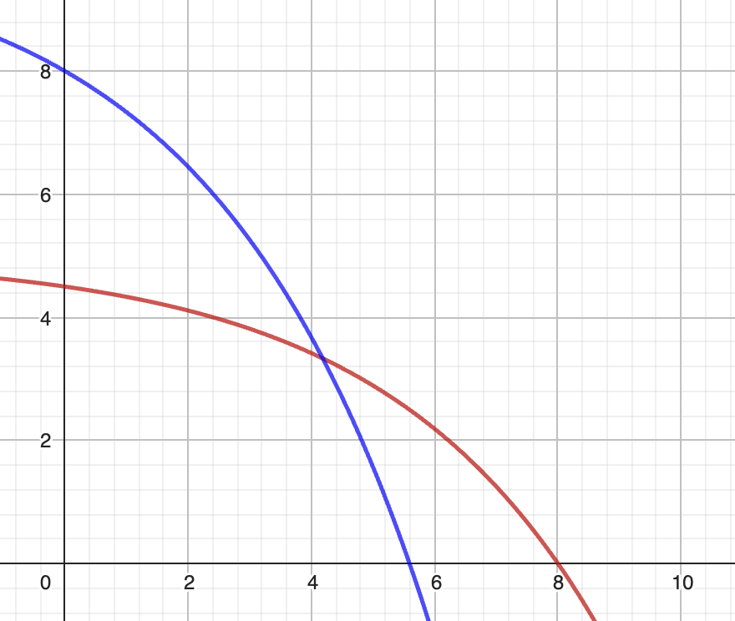
Here i have
$$δ=0.75, b_{H}=10,b_{L}=5,{\overline{u}}_{H}=2,{\overline{u}}_{L}=0.5$$
We see that they crosse exactly once
We note that utility is increasing down and to the left

c)

(ic) high type:

$$δ^{t_{L}}·\left(b_{H}-p_{L}\right)≤δ^{t_{h}}·\left(b_{H}-p_{h}\right) (1)$$

Low type:
$$δ^{t_{L}}·\left(b_{L}-p_{L}\right)≥δ^{t_{h}}·\left(b_{L}-p_{h}\right) (2)$$

d)
show
$$t_{L}=t_{H}⇔p_{L}=p_{H}$$

$$t_{L}=t_{H}⇒\left(1\right)⇔p_{H}≤p_{L}$$
$$⇒\left(2\right)⇔p_{H}≥p_{L}$$
$$p_{H}=p_{L}⇒\left(1\right)⇔t_{L}≥t_{H}$$
$$\left(2\right)⇒t_{L}≤t_{H}$$
Thus in seperating EQ we can never have equality in either

$"t_{L}>t_{H}, p_{L}>p_{H}$”
This is never a viable pooling EQ since this makes the high bundle strctly better for both parties
Both prefer low p and low t
In this instance L chooses H’s bundle

$"t_{L}<t_{H}, p_{L}<p_{H}$”
Same argument
H chooses L’s bundle

AFC $t_{L}<t_{H}, p_{L}>p_{H}$
We draw

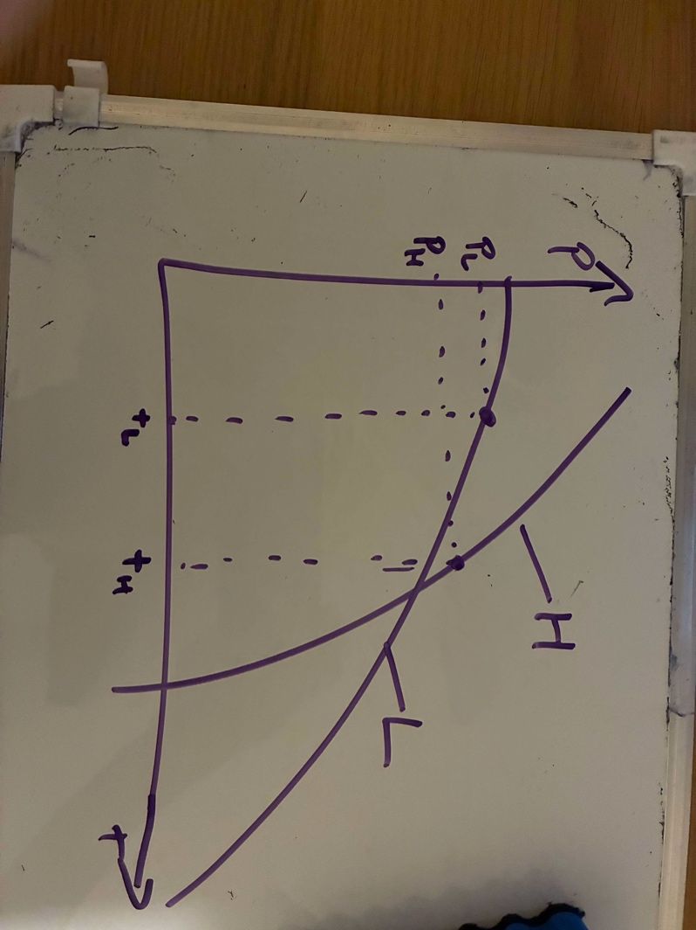
Seeing that if H takes the bundle ment for L he increases his utility

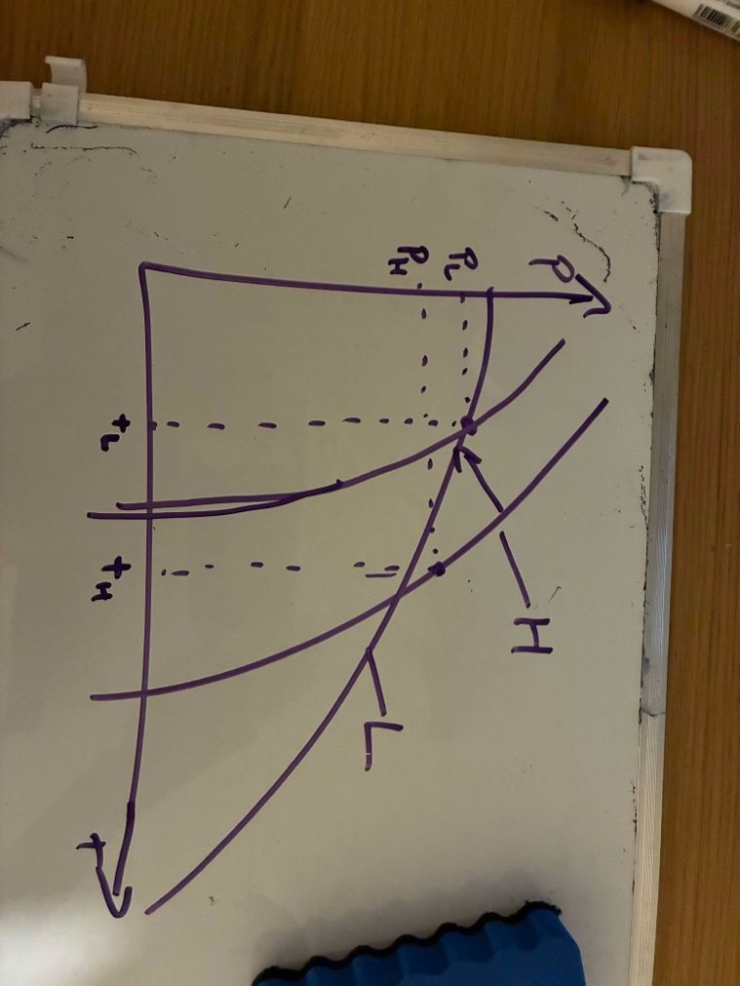
Thus this is not a seperating EQ

Thus any seperating EQ must satisfy
$$p_{H}>p_{L},t_{H}<t_{L}$$

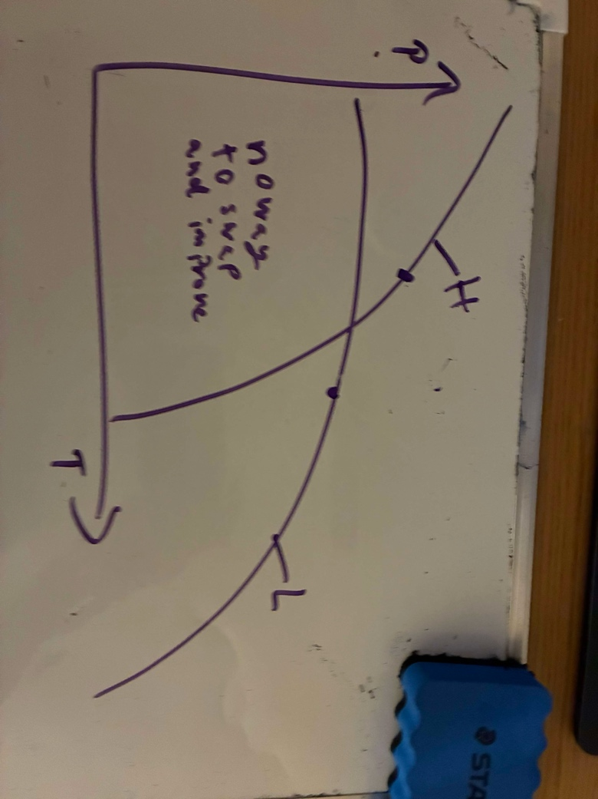

Thus this is might be a vialble seperating EQ

e)
assuming that everything is logable which probably isent so bad and if a somethin isent logable we know that there will either be no solutions or a constraint will never be binding
$$δ^{t_{L}}·\left(b_{H}-\frac{b_{L}}{2}\right)≤δ^{0}·\left(b_{H}-\frac{b_{H}}{2}\right)⇔t_{L}≤\frac{\log\left(b_{H}-\frac{b_{H}}{2}\right)-\log\left(b_{H}-\frac{b_{L}}{2}\right)}{\log\left(δ\right)}$$
$$δ^{t_{L}}·\left(b_{L}-\frac{b_{L}}{2}\right)≥δ^{0}·\left(b_{L}-\frac{b_{H}}{2}\right)⇔t_{L}≥\frac{\log\left(b_{L}-\frac{b_{H}}{2}\right)-\log\left(b_{L}-\frac{b_{L}}{2}\right)}{\log\left(δ\right)}$$

